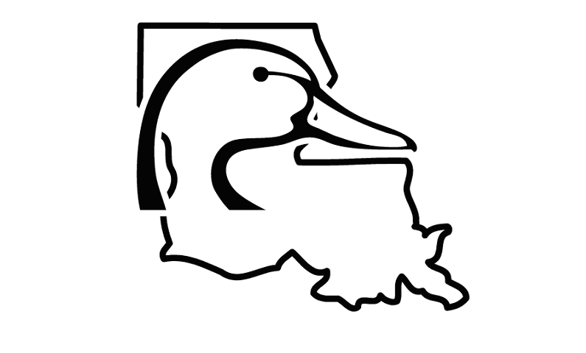
Ducks Unlimited
Carencro Sponsor
DUCKS UNLIMITED

CARENCRO CHAPTER

2020 SPONSORSHIP INVOICE
Name:

Company:
Sponsor Banquet
Wednesday, August 26, 2020
Jefferson Street Pub
500 Jefferson Street
Lafayette, LA 70501

Address:

City: State: Zip:

E-mail: _________________________________________________

2020 Sponsorship Package – Bronze -$325
Package includes: One year DU Membership; 2020 Sponsor License Plate and Hat; Special Carencro Sponsor Gifts for Men and for Women; 2 Sponsor Banquet tickets to Jefferson Street Pub, 1 Members Banquet ticket to Carencro Civic Center.
Sponsors Only gun raffle entry for Sponsors gun drawing at the Members Banquet. You do not have to be present to win.

2020 Sponsorship Package – Silver -$500
Package includes: Bronze package items listed above plus 2 tickets for the Sponsors Only Gun.

2020 Sponsorship Package – Gold -$1,000
Package includes: Bronze package items listed above plus 4 tickets for the Sponsors Only Gun.

Reserved Table for Members Banquet $400
Includes: One Reserved table for 7 at the Members Banquet (1 sponsor and 6 guests);
6 Member Banquet tickets, each including 1 year DU membership

- $325  $500  $1000

# Sponsorship Package: $
# Members Banquet Reserved Table X $400: $_________________________
Total Charge: $_________________________

Payment Method:
❑ NEW Option – Online: Go to www.carencrodu.org and click on Events Tab Carencro Sponsor
❑ Check Enclosed (Make checks payable to Ducks Unlimited, Inc.)  Credit Card

Card Type: _____Master Card _____Visa _____American Express _____ Discover
Credit Card Number: Expiration Date:
Signature: Security Code: ____________

Please fill out completely and return with payment method to:
Ted Hoyt, Ducks Unlimited
Attn: Tammy Sonnier
315 S. College Rd. Suite 165, Lafayette, LA 70503

Questions contact: Lance Hargrave @ 337-254-8025; Ted Hoyt @ 337-234-1012;
Dale Bourgeois @ 849-2949; John Harris @ 337-983-6322

